DTP – Dynamic Trunking Protocol

Dynamically negotiate the creation of trunks

Cisco proprietary protocol

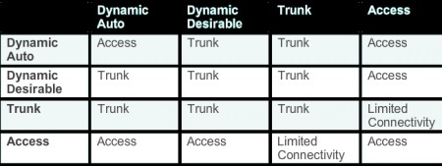

It is recommended that you not use DTP

Instead, set the trunks manually

And disable the use of DTP explicity with the interface level command: #switchport nonegotiate